PRUEBA DE ACCESO A CICLOS FORMATIVOS

HEZIKETA ZIKLOETARA SARTZEKO FROGA

JUNIO 2008 / 2008KO EKAINA

GOI MAILAKO ZIKLOAK / CICLOS DE GRADO SUPERIOR

ARLO ESPEZIFIKOA / PARTE ESPECÍFICA

IDIOMA EXTRANJERO
ATZERRIKO HIZKUNTZA

(INGLÉS)

Abizenak
Apellidos

Izena Ordena Zkia.
Nombre ______________________________________ Nº orden __________

Lurraldea N.A.N. Adina
Territorio D.N.I. Edad

Ikastetxea
Centro

READING

CAN’T WRITE? DON’T WRITE by David Sexton.
First there was IDS, now Michael Howard’s wife is revealed as a would-be novelist. The world is too full of amateur authors.
NO other book is quite so completely and utterly worthless as a mediocre novel. A mediocre guide to trees or to cheese can have its uses for those who don't have anything better on the subject to hand. A history book or biography, however dull, contains some facts that may prove handy to somebody one day. Atlases, dictionaries, anthologies and instruction manuals, however uninspired, all have some little utility. But a lifeless novel has no value whatsoever. Worse than worthless, it's positively a menace - for any time spent in reading dim, failed novels is so much time lost, time subtracted from life. In fact, a blank book is more desirable than a book defaced with such redundant type. At least blank pages can be used for shopping lists or doodles.
Yet duff novels continue to pour from the presses. Iain Duncan Smith's novel has been much ridiculed. We have just learned that Sandra Howard, the wife of his successor, is another novelist in the bud, having composed a thriller called Love in High Profile. Much of this unwanted fiction barely makes it into the bookshops. But for every novel worth reading that appears, there are dozens, hundreds even, of others published that really are not worth anybody's time at all.
“Evening Standard” (10/XI/03)
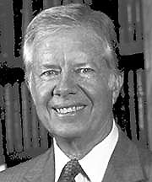
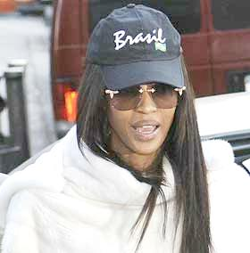


- COMPLETE THE SENTENCES USING INFORMATION FROM THE TEXT ( 5 points)

- A mediocre guide to trees or to cheese…...............

- A history book or biography…..................

- Atlases….......................

- Dictionaries…................

- A blank book…................

2. VOCABULARY: (3 points)

- Find in the text a SYNONYM for the following words:

- Absolutely..................................
- Poor, second-rate.......................
- Boring, tedious.........................

- Find in the text an ANTONYM for the following words:

- Valuable ........................................
- Negatively.....................................
- Husband........................................

3. WRITE A PARAGRAPH ABOUT THIS TOPIC. (No more than 60 words)
(6 points)

“Nobody tries to give a piano recital without having learned first to play the piano. Yet some people think that they can write a novel by some natural gift”.

.....................................................................................................................................................................................................................................................................................................................................................................................................................................................................................................................................................................................................................................................................................................................
.........................................................................................................................................................................................................................................................................................

GRAMMAR

A) PRESENT SIMPLE AND PRESENT CONTINUOUS.

1) READ THESE SENTENCES FROM THE TEXT. WHICH VERBS ARE IN THE PRESENT SIMPLE AND WHICH IN THE PRESENT CONTINUOUS? (2 points)

- Panasonic claims it is the world’s smallest digital camera...............................
- It also acts as an MP3 music player. ................................................................
- The firm is expecting huge sales in the run-up to Christmas. ..........................
- Other companies are developing cameras which also use memory cards .................................

2) COMPLETE THE TABLES: (3 points)

THETHE PRESENT SIMPLE
Affirmative | Negative | Interrogative | Short answer
We work with computers |  |  | Yes,…  No,…

THE PRESENT SIMPLE thethe SIMPLE (3rd person singular)
Affirmative | Negative | Interrogative | Short answer
She designs appliances |  |  | Yes,…  No,…

PRESENT CONTINUOUS
Affirmative | Negative | Interrogative | Short answer
He is running a PC program. |  |  | Yes,…  No,…

3) COMPLETE THE RULES WITH “PRESENT SIMPLE / PRESENT CONTINUOUS” (1 point)

- We use the __________________ to talk about habits or regular activities
- We use the __________________ to talk about things that are always true
- We use the __________________ to talk about things that are in progress now.
- We use the __________________ to talk about temporary situations.
- We use the __________________ to talk about future arrangements.

4) COMPLETE THE SENTENCES WITH THE VERBS IN BRACKETS IN THE PRESENT SIMPLE OR THE PRESENT CONTINUOUS. (4 points)

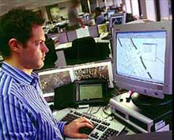

I usually work with a laptop, but today I’m working with a desktop PC

- Steve ___________ (play) football every weekend, but at the moment he ______________ (watch) TV.
- The designers _________________ (work) on a new digital camera model now. They often ________________ (produce) a new design every month.
- It ______________ (not rain) very much in Egypt, but we __________ (look for) shelter now because it ___________________ (pour down).
- Don’t disturb Blanche, she _______________ (study). She __________ (not like) noises when she studies.
- Our neighbours ____________ (go) to New York next summer.

5) WRITE FULL SENTENCES (INTERROGATIVE AND AFFIRMATIVE).
(5 points)

1- What/she /do? She /work/ hospital.
2- What / she / do / now? She / play / golf.

3- They / work / at the moment? No / they / not.
4- Where / she / live? She / live / in a country house.

5- You / want / to eat? Yes / want / toast.

VOCABULARY

A) NEW TECHNOLOGIES

1) MATCH THE ACRONYMS IN COLUMN A WITH THEIR MEANING IN COLUMN B AND THEN WITH THEIR NAME IN FULL IN COLUMN C.
( 9 points)

A | B | C
- P.D.A.  - U.S.B.  - C.P.U.  - T.F.T.  - R.A.M.  - L.C.D.  - D.V.D.  - V.C.D.  - S.M.S. | - System used to send messages between mobile phones.  - Memory used by a PC to perform certain operations.  - Compact Disc for playing images and sounds (films)  - Small gadget which performs some of the operations a PC can perform.  - Special type of small screen  - New type of screen, much slimmer than traditional ones.  - Special format for images in PCs.  - Main body of a desktop PC where most of the hardware is installed.  - Special port for plugging hardware to a PC. | - Central Processing Unit  -Random Access Memory.  - Liquid Crystal Display  - Universal Serial Bus.  - Short Message System  - Digital Video Disc  - Personal Digital Assistant  - Video Compact Disc.  - Thin Film Transistor

.....................................................................................................................................................................................................................................................................................................................................................................................................................................................................................................................................................................................................................................................................................................................................................................................................................................................................................................................................................................................................................................................................................................................................................................................................................................................................................................................

2) COMPLETE THE SENTENCES. USE THE ACRONYMS FROM EXERCISE 1. (4 points)

- The hard disc of a PC is inside the _______

- I sent my girlfriend a ________ 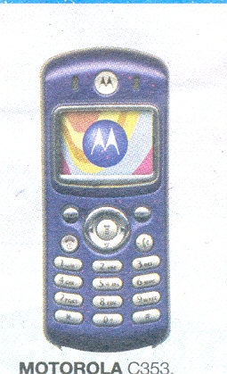

- You can connect your digital camera to the PC through the _____.

- My older screen was very big, and I had little room on my desk, so I’ve bought a _______ screen
- I need an agenda, and I like music, so I think I’ll buy a _______. 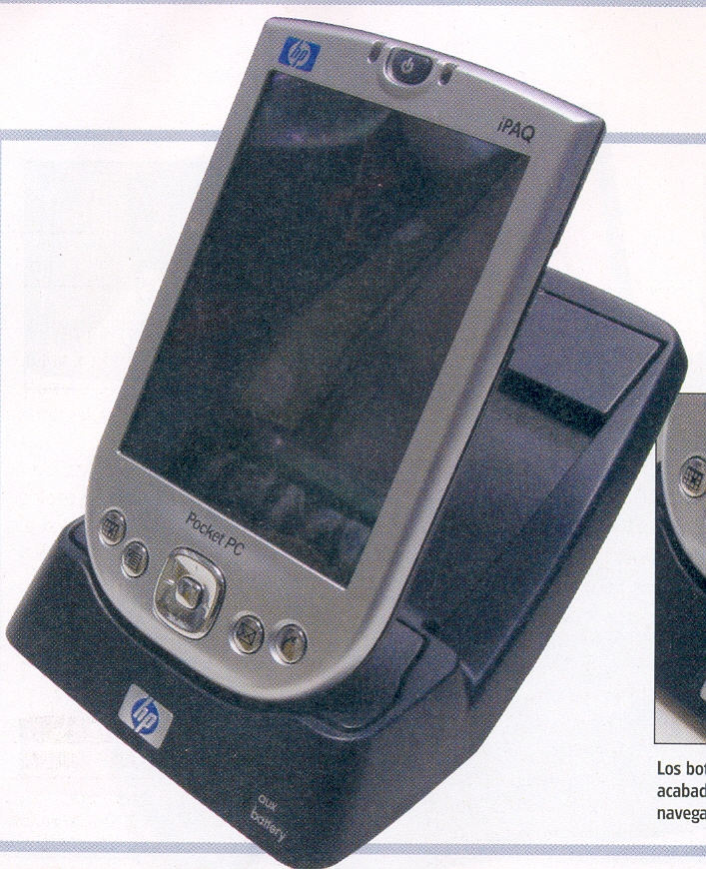
- I’ve seen that film. I hired the _________ last weekend.

- This calculator doesn’t have a TFT screen, it is an ________.

- My PC has 256 Mb of ___________ .

WRITING

Clock Barn Lane
Godalming
Surrey
11 March, 2008

The Headmaster
English Language Institute
28 Carson Street
Glasgow

Dear Mr. Rowland,

I am writing to complain about the behaviour of some of your students at your school, which is opposite my house.

Firstly, on the evening of 16 January, I was disturbed by some music, which was being played at a very high volume. Furthermore, when I rang up to complain, my request was ignored. To make matters worse, at about 2 a.m. I was woken by a group of students shouting and fighting in the street.

I suggest that you look into this matter at once. Please ensure that this sort of incident does not happen again.

Yours sincerely

Stephen Bradley

Clock Barn Lane
Godalming
Surrey

11 March 2008
Dear John,

Thank you for your last letter. I’m sorry I haven’t written for so long, but you can imagine I have been very busy with the new job.
Anyway, the reason I’m writing is that I saw Stuart the other day and he asked after you. He’s just got back from New Zealand and he wants to get in touch with everyone. It seems he had a really good time there, but I’m sure he will tell you all about it personally.
By the way, I’m having a party here next weekend. I’m not sure yet who’s coming, but there’ll be some people from the office plus a few others. Let me know if you can make it.
I’m looking forward to seeing you again.

Love

James

1-READ THE LETTERS AGAIN AND ANSWER THESE QUESTIONS. (2 points)

  - Which letter uses contractions?
  - Which letter uses colloquial language?
  - Which letter uses polite expressions?
  - Which letter is a “formal letter” and which an “informal letter”?

2-RE-READ THE LETTERS AND COMPLETE THE CHART BELOW WITH THE INFORMATION IN THE BOX. (3 points)

“Yours sincerely” “Dear ____” contractions and colloquial language
“Dear Sir/Madam” “Best wishes” On the left

Writing tips
Formal letter | Informal letter
- Write your name and address on the top-right corner.  - Write the addressee’s address __________, just after the date.  - Begin with _________ or “Dear Mr./Mrs./Miss/Ms. Smith”  - Do not use contractions  - Use polite expressions  - If you begin with “Dear Sir/Madam”, finish with “Yours faithfully”. If you begin with “Dear Mr./Mrs./Miss/Ms. Smith”, finish with _____________ | - Write your name and address on the top-right corner.  - Begin with __________ and write a comma after the name.  - You can use___________________.  - Finish with “(Lots of) Love” or ______________.

4-WRITE A FORMAL LETTER COMPLAINING ABOUT AN ALARM CLOCK YOU BOUGHT AND WHICH ISN’T WORKING PROPERLY, AND ASKING FOR A REFUND. USE THE MODEL LETTER IN EXERCISE 1 AND THE WRITING TIPS ABOVE. (10 points)

...................................................................................................................................................................................................................................................................................................................................................................................................................................................................................................................................................................................................................................................................................................................................................................................................................................................................................................................................................................................................................................................................................................................................................................................................................................................................................................................................................................................................................................................................................................................................................................................................................................................................................................................................................................................................................................................................................................................................................................................................................................................................................................................................................................................................
...........................................................................................................................................................................................................................................................................................................................................................................................................................................................................................................................................................................................................................................................................................................................................................................................................................................................................................................................................................................................................................

